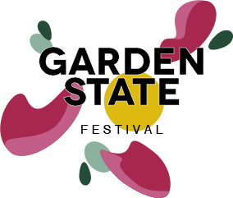

Submission Form – Please fill out and send to – hello@gardenstatefestival.com.au
Business Name: (if applicable)
Event Contact Name:
Event Contact Phone Number:
Event Contact E-mail:
Event Title:
Event Location:
Event Start & Finish Time:
Event Blurb:
Event Hero Image: (attach)
Maximum no. of Participants:
Will this be a Free Event? (will still be registered)
Will this be a Priced Ticketed Event?
If Priced Ticketed what value per ticket?
Will you offer Full Price & Concession Price Tickets?
Will this event be an Open Studio/Exhibition/Installation? (no registrations required)
Access Details – Is the event location wheelchair friendly/pram accessible etc…?

Microgrant (optional)

Microgrants of $500 are available for creatives, makers, organisations, and business to support you to host an event, explore and create as part of the 2021 inaugural Garden State Festival.

Would you or the organisation wish to apply for a Microgrant?
How will the Microgrant be used?
Attach any additional information to support your application
Terms and Condition
Cancellation or changes to event, once approved by Festival Organisers, is not possible after the 28th of March 2022 on the launch of the program.
Ticket Sales will be non-refundable or transferrable to another if a participant cancels their attendance or is unable to attend.
Attendee List for your Event will be sent to you 24 hours prior to your event start time
You will be responsible to run the event on the day, including checking off attendee list upon entry to the venue etc.
In joining the program of Garden State, participating individuals, organisations and businesses are agreeing to running a COVID safe event, adhering to current government public health orders and advice on density limits and covid safe practices including but not limited to cleaning and hand sanitising stations, ensuring participant have shown vaccination status etc.
In joining the program of Garden State, participating individuals, organisations and businesses will have adequate public liability insurance and be committed to hosting a safe and accessible event.

